Setting Up Backups

Step #1 Installing the Software
- Download Software: ToDo Backup Free
  - Go to https://software.bullcityfinancial.com/install/Client_Services_Only/ and download:
    - TB_Free_Installer
  - Install Software
    - When installing ToDo Backup, select the “free” version when asked.
  - Install any components as requested by Installer
Getting started with ToDo
- Open ToDo and click “Create Backup”
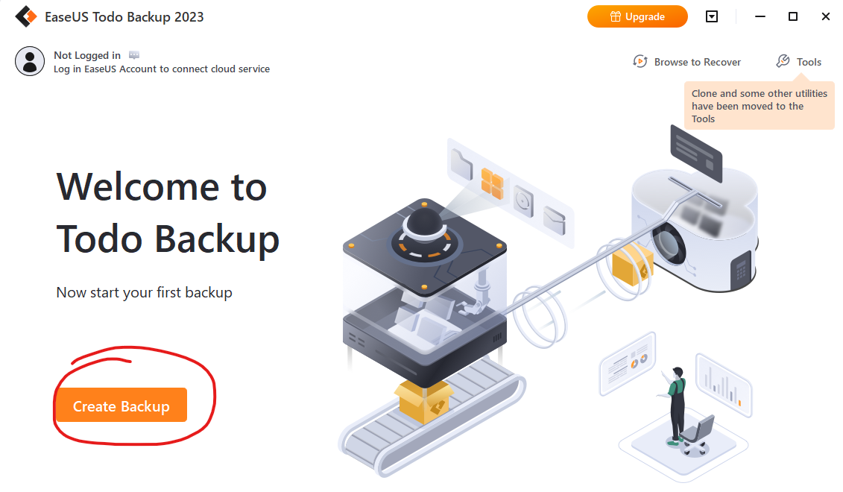
- Then under “Select what you want to back up” choose “Disk”
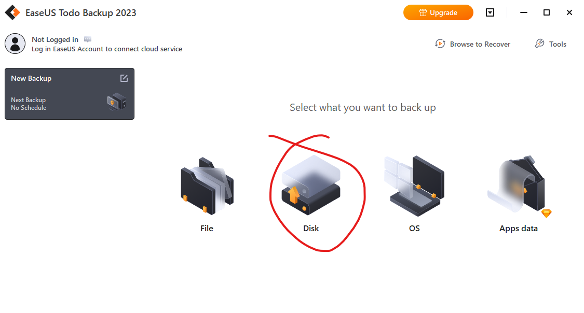
  - Then choose your main hard disk and click “OK”.
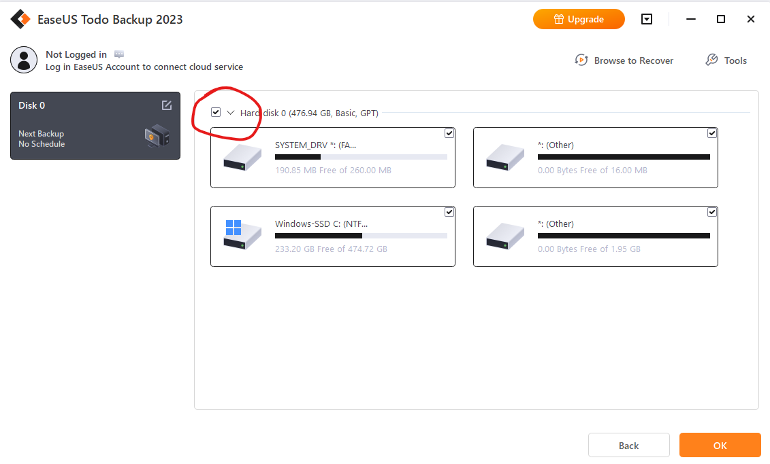

- Next we need to choose the Destination for the Backup. Click the Destination button
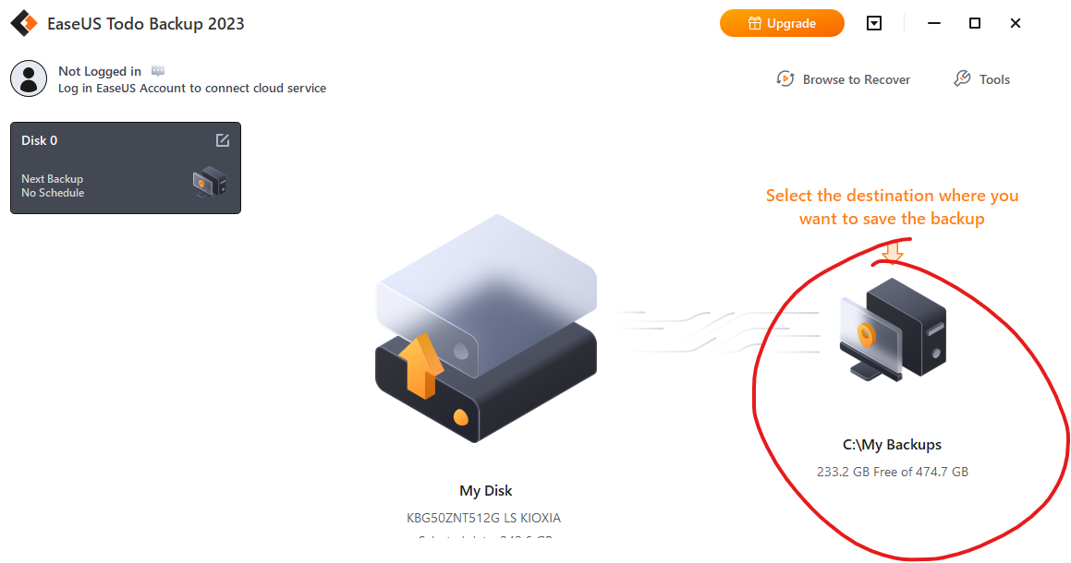
  - Now Choose “NAS”
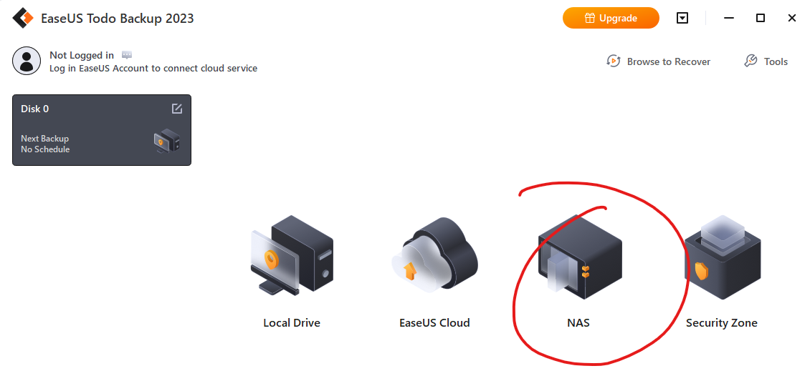
  - Click “Add NAS device” and a popup will appear.
    - For “NAS IP/Name” put: \\TS3420-NAS\Mgmt_Backup_Images
    - Display name can be anything, such as “TS3420-NAS”
    - Username is your CRS username (lower case)
    - Password is: BullCity2023$
    - Click “ok” once filled in
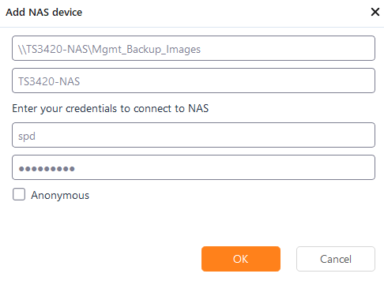
  - Now select the NAS you just added and click “OK”
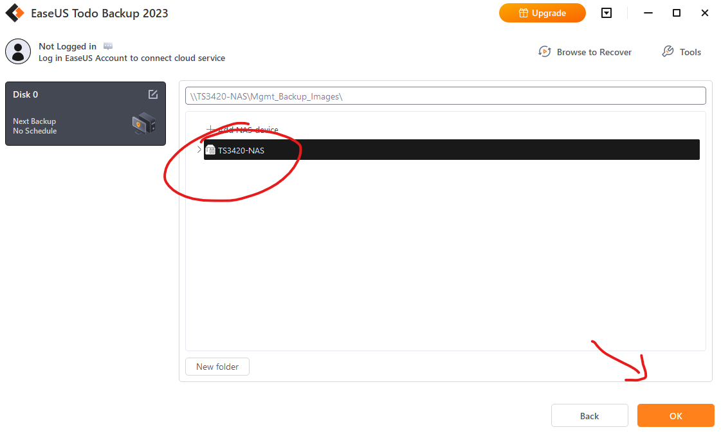
  - Now your set up will show “My Disk” and the “NAS Backup” … next click “options” in the bottom left
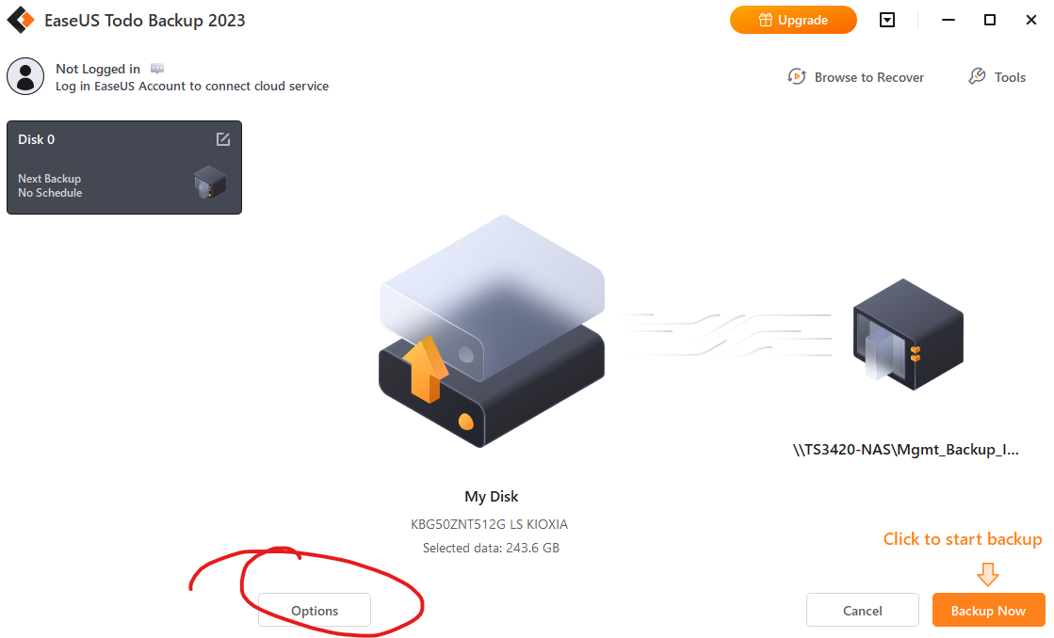
    - While on the “Backup Options” tab choose “Encryption”
      - Enable Encryption
      - PW: bullcity1976$$
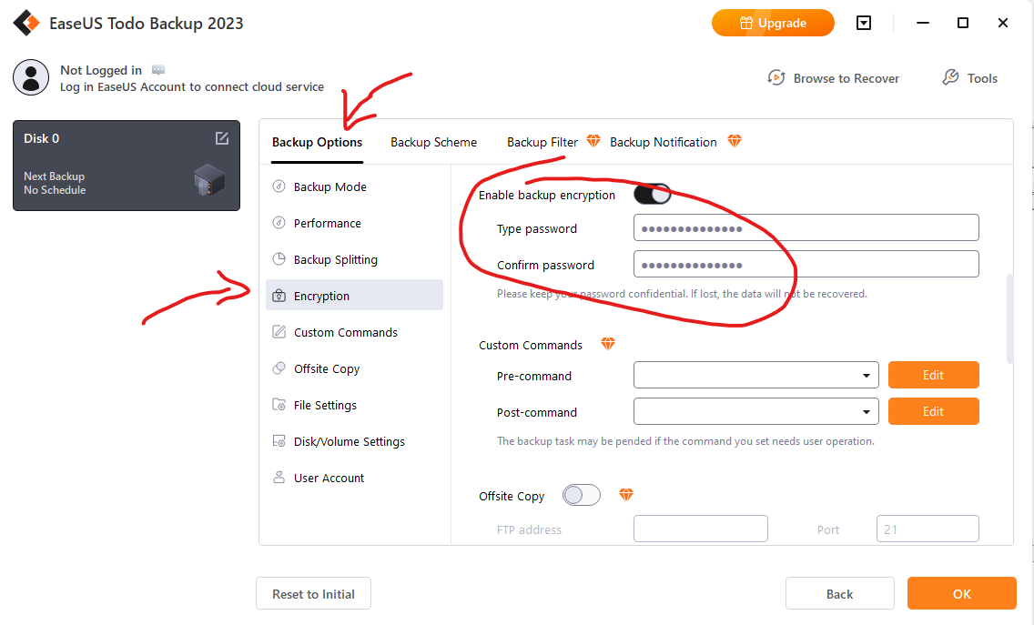
    - Then Select the “Backup Scheme” tab
      - Choose “Weekly” and select a day/time setup that works for you.
      - Select “Full” as the backup method.
      - Sroll down and check “Enable Reserve Strategy”
      - For “Preserve the last” enter “2” backups
      - Click “OK” when complete
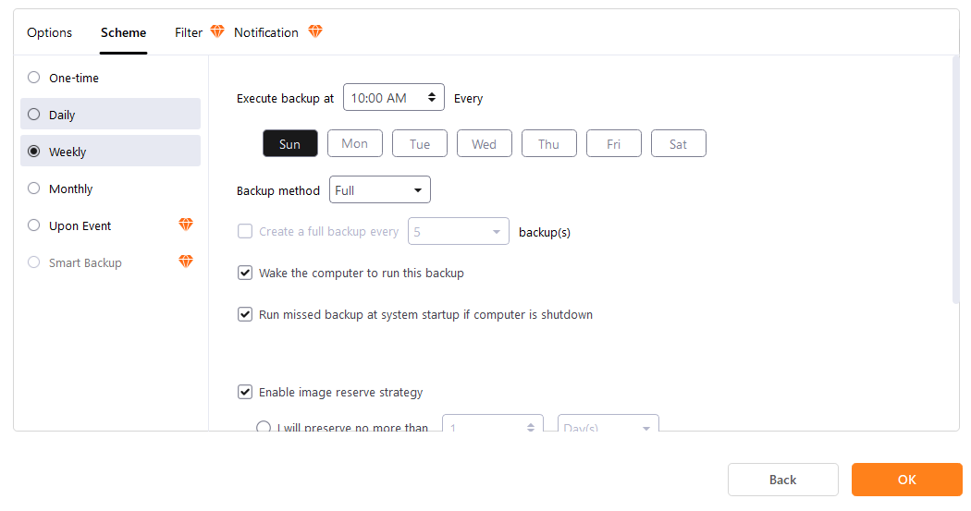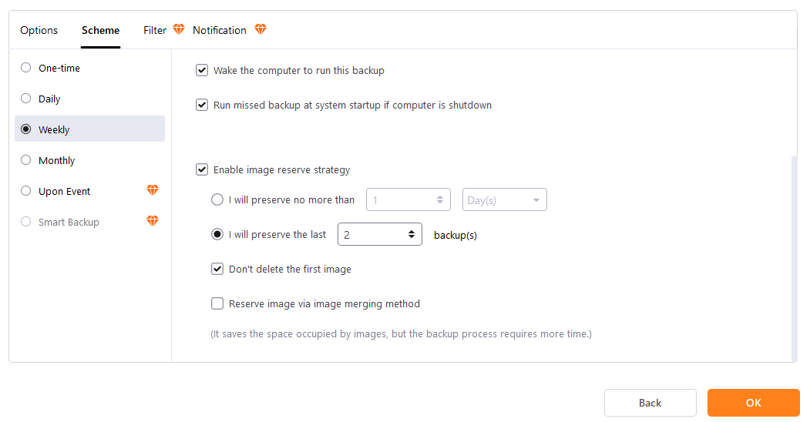

  - Now Choose “OK” in the bottom right
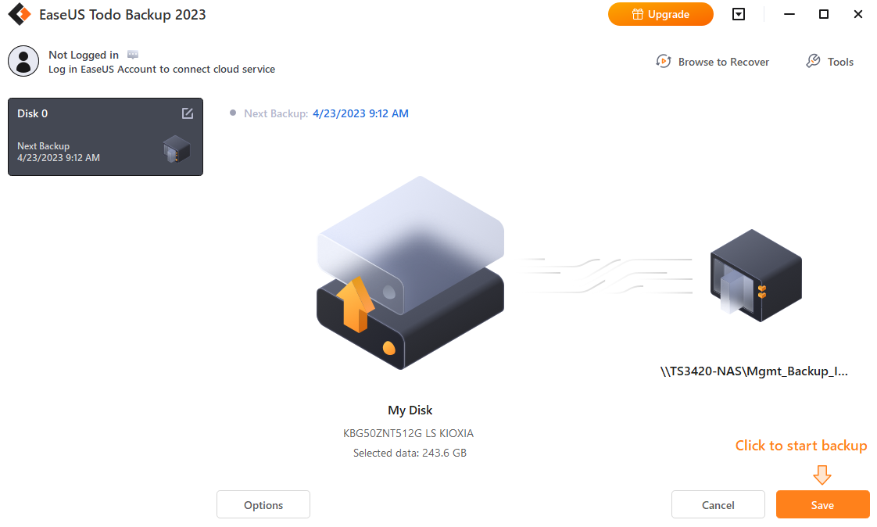
  - Your Backup schedule is now Saved, and will automatically run at the desired timeframe.
    - Choose “Backup Now” in the bottom right to run the backup for the first time
    - It will take 30-60 minutes the first time, and can be run in the background
      - All additional backups will be much faster
